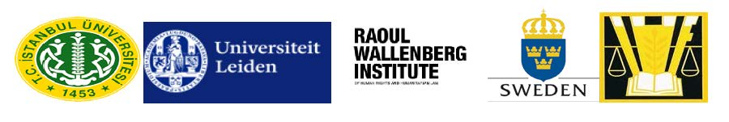

LAW ON THE BOSPHORUS VI
INTERNATIONAL SUMMER SCHOOL 2018
30 JULY-10 AUGUST 2018, ISTANBUL

FIRST CALL

HUMAN RIGHTS, TERRORISM AND REFUGEES

Istanbul University Faculty of Law – Leiden University, Leiden Law School
Criminal Law and Criminology Research and Application Centre
Raoul Wallenberg Institute of Human Rights and Humanitarian Law

With the support of the Raoul Wallenberg Institute of Human Rights and Humanitarian Law, Istanbul University Faculty of Law, Criminal Law and Criminology Research and Application Centre and Leiden University, Leiden Law School will be organizing the sixth edition of the joint International Summer School, to be held in Istanbul, between the 30th July and 10th of August 2018.

As with its previous fifth editions, the 2018 joint ‘Law on the Bosphorus’ Summer School will be oriented on transnational Human Rights Law, focusing within that domain on a particular theme. The focus of the 2018 Summer School will be on the relationship between Human Rights Law, terrorism and refugees. Amongst others, themes touched will be:
- Rights of refugees
- International human rights law
- Terrorism in international law
- Refugees in international law
- Comparative criminal law in the arena of refugees and terrorism
- Combating terrorism

PROGRAM FORMAT: The summer school will consist of daily lectures, mooting clinics and mooting sessions which will take place at the closing of the Summer School. The program also consists of diverse excursions to Criminal Justice and Migration Institutions in Turkey, i.e. to Police headquarters, Istanbul Justice Palace and a penitentiary institution. These excursions will include unique ‘on location’ lectures by experts in the field. The student presentation sessions will take place on the final day of the summer school. At the closing ceremony, special certificates will be awarded to the best team of students as well as to the best individual student presenter.

VENUE: The program will be held in Istanbul University Faculty of Law’s historic premises at the heart of Istanbul, Turkey. The Summer School will take full advantage of the unique opportunities offered by this unique venue, embedding the academic program within the excitement and beauty of Istanbul.

TUTORS: The lectures and clinics of the Summer School will be delivered by lecturers from Leiden Law School and Istanbul University Faculty of Law as well as other guest lecturers.

FOR ENQUIRIES AND APPLICATION: At summerlaw@istanbul.edu.tr. Applicants will be asked to submit a request for an application form and return the form together with a Curriculum Vitae, letter of motivation describing their purpose in attending the Summer School and an academic letter of reference. Criteria for applications are that participants have a good basis in Human Rights Law and command of the English language. Further details regarding the academic program and social activities will be provided upon application.

FEE: The fee for the 2018 Summer School is 200 Euros for students and 300 Euros for non-students. The fee will include the lunches, boat trips, opening and final dinners and social programmes.

Please transfer the registration fee to the following bank account number:
Bank Account Info:
Full Name of the Bank | T.C. Ziraat Bankasi
Full Name of the Bank Account | İ.Ü. Hukuk Fakültesi Eğitim Öğretim ve Yardımlaşma Vakfı
The Address of the Bank | Beyazıt-Istanbul TURKEY
Branch/Branch Code | Beyazit/606
Bank Account (IBAN) | TR 35 0001 0006 0634 5229 39-5010
SWIFT CODE | TCZBTR2A

Deadline For application: 1st of April 2018
For info please visit: http://insanhaklari.istanbul.edu.tr/
Application Form

